Norms and Values
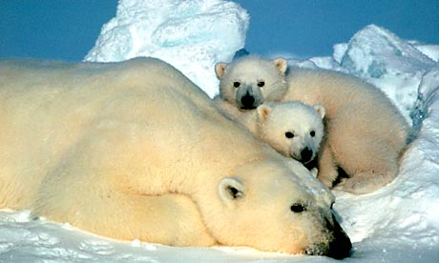
Value – a principle, standard, or quality considered ________________________

*indicates the degree to which something is good or bad
*tends to revolve around concepts of morality, aesthetics, and achievement


Attitude – a belief or feeling that _____________________________________
in a particular way to something

Do attitudes affect actions?

-How you think about something influences how you behave…
  - Example: feel dislike act unfriendly

Actions can also affect attitudes!
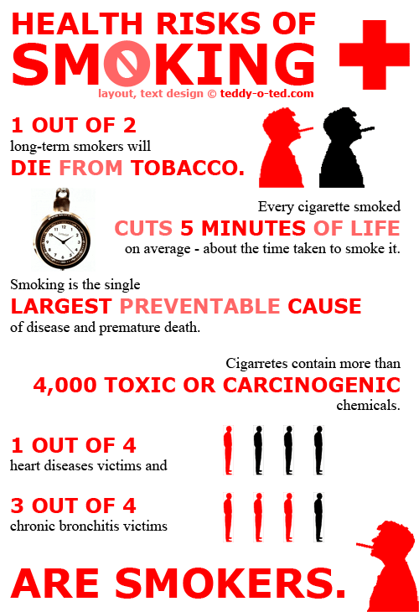
- Cognitive Dissonance- occurs when a person holds two or more ________________ ___________________________________________
    - Example: smoker knows that smoking leads to lung cancer

    - How do they reduce Cognitive Dissonance?
- change their attitude
- change their behavior

- ____________________________ can also affect attitudes! (Zimbardo Prison study)
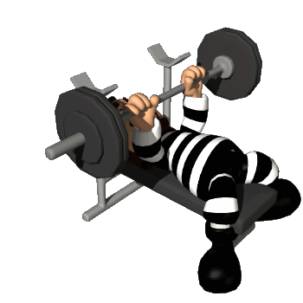

  - Role playing (such as becoming married or beginning a
new job) can cause you to strive to follow social
prescriptions, which then may make you adopt those attitudes.


Attitude Persuasion Methods
- Central Route to Persuasion: occurs when interested people
focus on the ___________ and respond with favorable thoughts

- Peripheral Route to Persuasion: occurs when people are
influenced by _______________, such as a speaker’s attractiveness

Social norms: an unwritten but understood rule for ______________________________

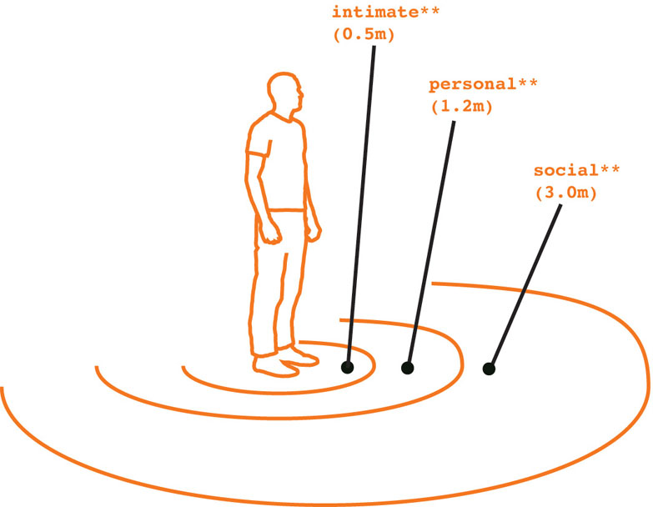
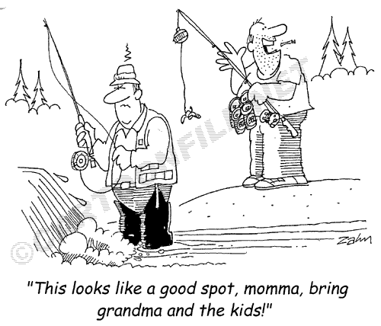
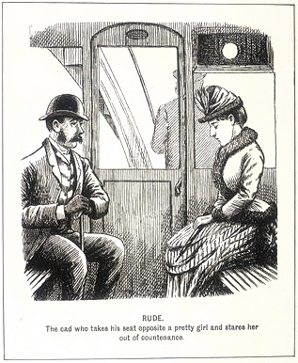

Conformity: adjusting one’s behavior or thinking to _______________________________
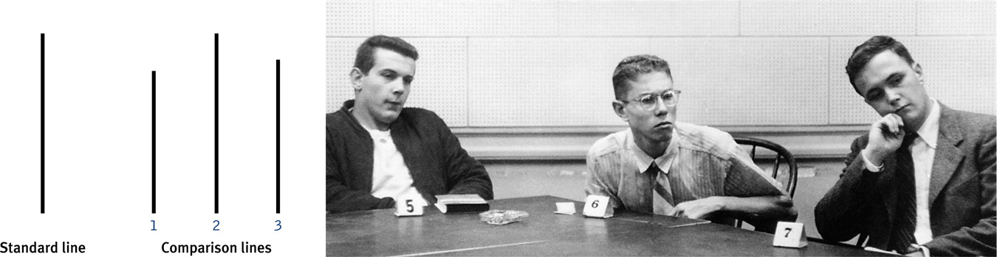 **Asch’s conformity exp.

Conditions that strengthen conformity: one is made to feel __________________, group has at least ____________ people, group is _____________, one admires group’s ________, others in the group ______________ one’s behavior, one’s culture strongly encourages ______________________________

Reasons for Conforming:

Normative influence: resulting from a person’s desire to
______________________________________________
Informational influence: resulting from one’s willingness to
_____________________________________________

Obedience: occurs when you change your opinions, judgments, or actions because someone in a position of authority __________________________
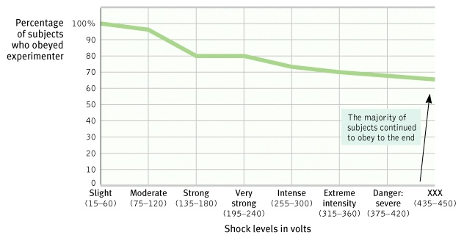
- 2/3 of all participants would shock a learner to death if told to do so in Milgram’s Study of Obedience
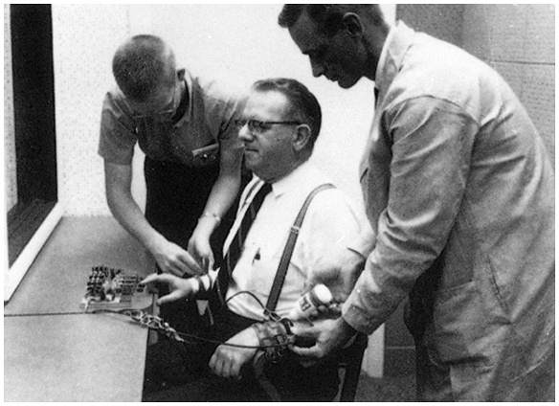
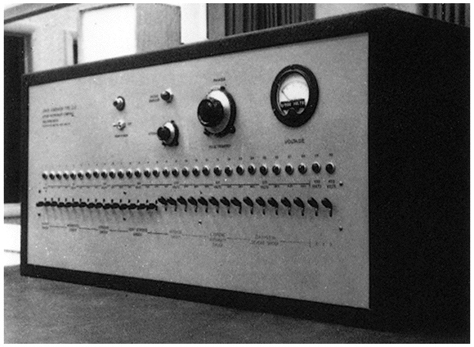


Values of Love:
- Passionate Love: an _____________ of intense positive absorption
in another, usually present at the beginning of a love relationship
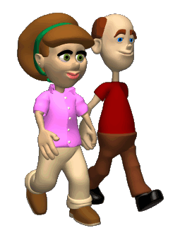

  - Usually present at the __________________ of relationships

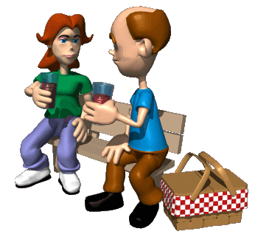
- Companionate Love: the deep ______________________
we feel for those with whom our lives are intertwined
  - _______________ and _______________________
help make companionate love work

